Q1 2026 Sales Performance Report

Acme Corp
Prepared by: Alex Carter
2026-04-01

Executive Summary
[ Provide a high-level summary of the report's key findings and recommendations. Replace this placeholder text. ]

Key Metrics
Performance Overview
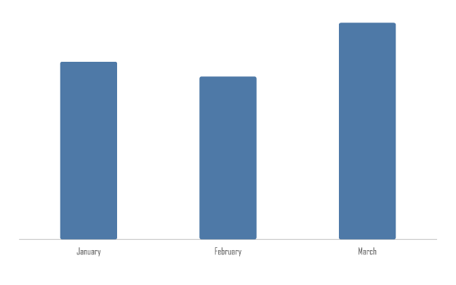
Revenue Trend  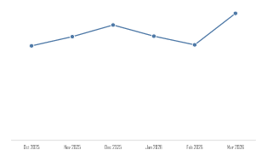 | Revenue by Channel  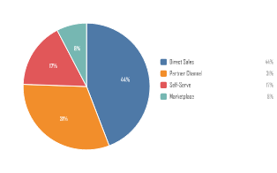

Spend Breakdown
Operating Spend by Category
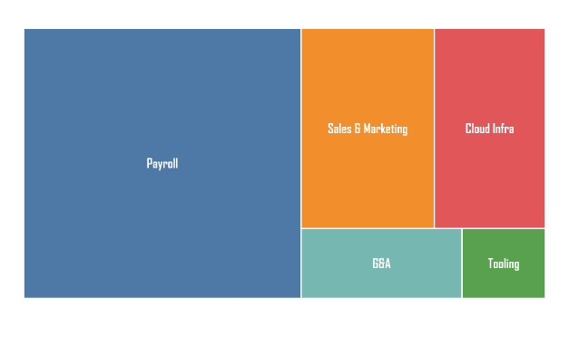

Regional Performance
Region | Q1 2026 | Q2 2026 | Total
APAC | $31,700.00 | $34,200.00 | $65,900.00
EMEA | $41,800.00 | $46,500.00 | $88,300.00
North America | $58,200.00 | $61,400.00 | $119,600.00
Total | $131,700.00 | $142,100.00 | $273,800.00

Detail
Metric | Value | Note
Total Revenue | $131,700 | Up 12% from Q4 2025
New Clients | 18 | Target was 15
Avg Deal Size | $7,317 | Down 3% from Q4 2025

Findings
[ Detail your analysis, observations, and conclusions. ]
- Finding one
- Finding two
- Finding three

Recommendations
[ Outline your recommended next steps based on the findings above. ]

